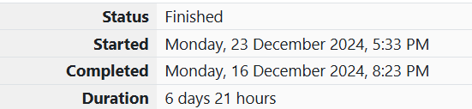

ROLL NO.: 241801281

NAME: SUJITHA NEELAKANDAN VIGNESHWARI

WEEK 04-01 PRACTICE WEEK

1.OBJECTIVE

Alice and Bob are playing a game called "Stone Game". Stone game is a two-player game. Let N be the total number of stones. In each turn, a player can remove either one stone or four stones. The player who picks the last stone, wins. They follow the "Ladies First" norm. Hence Alice is always the one to make the first move. Your task is to find out whether Alice can win, if both play the game optimally.

CODE:

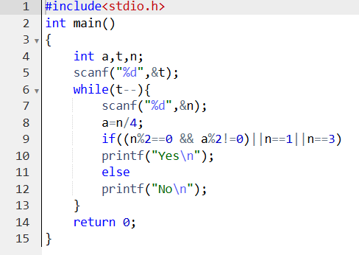

OUTPUT:

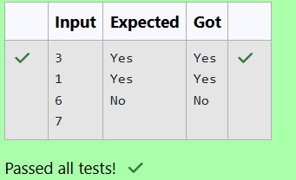

2.OBJECTIVE:

Given a number, you must determine the sum of the number of holes for all of its digits. For example, the number 819 has 3 holes.

CODE:

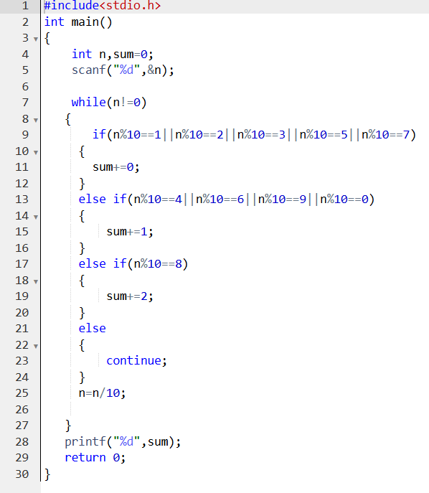

OUTPUT:

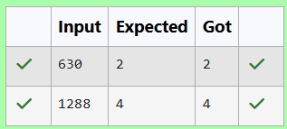

3.OBJECTIVE:

Now Manisha, being a keen observer suggested that we could actually minimize the number of coins required and gave following distribution {$1, $2, $3}. According to him any item can be purchased one time ranging from $1 to $5. Everyone was impressed with both of them. Your task is to help Manisha come up with a minimum number of denominations for any arbitrary max price in Philaland.

CODE:

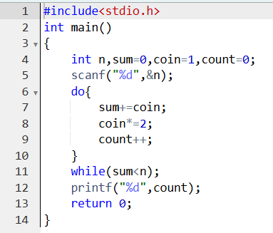

OUTPUT:

